|  |  |  |  |
| --- | --- | --- | --- |
| \\lyng-dc1\StaffShared\Learning Bugs Animals ALL subjects\characters bugs animals\Cyril the Snail - History.jpeg**Lyng Primary School Knowledge Organiser** | | | |
| **History Topic** | **How have women change the world?** | Year 1 | Summer 1 |

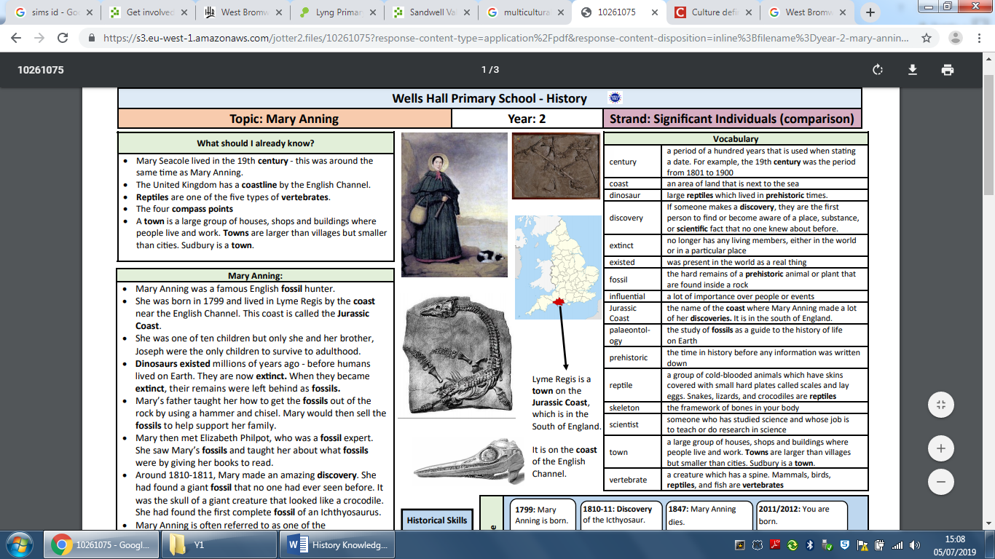

**Background information for parents and teachers**

Children will study famous women from around the world and the contribution they have made to art, history and geology.

Amelia Earhart was an American aviator who set many flying records and championed the advancement of women in aviation.

Mary Anning was a British palaeontologist who discovered new dinosaurs and contributed to important changes in scientific thinking.

**Hook**

Bury items in a small pot, cover with plaster of Paris and hide in the forest. They can then use a teaspoon to find their fossil.

**TRIP/VISITOR**

Visit to the farm

|  |  |
| --- | --- |
| **What Step On and Goldilocks words will I use?** | |
| **Spelling** | **Definition** |
| extinct | no longer has any living members, either in the world or in a particular place existed was present in the world as a real thing fossil the hard remains of a prehistoric animal or plant that are found inside a rock influential a lot of importance over people or events. |
| discovery | If someone makes a discovery, they are the first  person to find or become aware of a place, substance, or scientific fact that no one knew about before. |
| dinosaur | large reptiles which lived in prehistoric times. |
| century | a period of a hundred years that is used when stating a date. For example, the 19th century was the period from 1801 to 1900 coast an area of land that is next to the sea. |
| aviator | An aviator typically refers to a person who operates an aircraft. They may be a pilot, someone who flies an aircraft, or a member of the aircrew responsible for navigation, communication, or other tasks related to flying. |
| palaeontologist | A palaeontologist is a scientist who studies fossils to understand life in ancient times. They examine fossils, analyze data, and reconstruct the history of life on Earth. |

|  |
| --- |
| **When? (Timeline of key events)** |

1799: Mary Anning is born.

1810-11: Discovery of the Icthyosaur.

1847: Mary Anning dies.

1897: Amelia Earhart is born

1922: [Amelia Earhart sets altitude record for female pilots](https://worldhistoryproject.org/1922/10/22/amelia-earhart-sets-altitude-record-for-female-pilots)

1928: Amelia Earhart becomes first woman to fly across the Atlantic Ocean

1937: Amelia Earhart disappears

1939: Amelia Earhart is declared dead

“The world has used me so unkindly, I fear it has made me suspicious of everyone.”

Mary Anning

“[Use your fear... it can take you to the place where you store your courage.](https://www.azquotes.com/quote/1315741)”

Amelia Earhart

**Great Quotes**

**Our Storytelling Approach to enhance engagement**

|  |  |  |
| --- | --- | --- |
| **People:**  **Mary Anning** | **Place:**  England  Lyme Regis | **Problem:**  Inequality |

**Key People**

**Mary Anning**

• She was born in 1799 and lived in Lyme Regis by the coast near the English Channel. This coast is called the Jurassic Coast.

• She was one of ten children but only she and her brother, Joseph were the only children to survive to adulthood.

• Dinosaurs existed millions of years ago - before humans lived on Earth. They are now extinct. When they became extinct, their remains were left behind as fossils.

• Mary’s father taught her how to get the fossils out of the rock by using a hammer and chisel. Mary would then sell the fossils to help support her family.

• Mary then met Elizabeth Philpot, who was a fossil expert. She saw Mary’s fossils and taught her about what fossils were by giving her books to read.

• Around 1810-1811, Mary made an amazing discovery. She had found a giant fossil that no one had ever seen before. It was the skull of a giant creature that looked like a crocodile. She had found the first complete fossil of an Ichthyosaurus.

• Mary Anning is often referred to as one of the first palaeontologists – scientists who study fossils – and her work started to change our understanding of how the world has changed over time.

• Her work and discoveries can now be seen in the Natural History Museum in London.

**Amelia Earhart**

Amelia Earhart was a brave and adventurous woman who loved flying airplanes. She was one of the first female pilots to fly solo across the Atlantic Ocean, which is a big stretch of water between America and Europe. People all around the world admired her courage and determination. Amelia dreamed of exploring new places and breaking records in aviation. She believed that anyone, no matter their gender, could accomplish their dreams if they worked hard and believed in themselves. Even though she disappeared during a flight over the Pacific Ocean, her legacy continues to inspire people, especially young girls who dream of becoming pilots or adventurers.

**Agreed Outcome**

Answer the questions how and why Mary Anning and Amelia Earhart changed the world.

**Key Questions**

Who was Mary Anning?

Who was Amelia Earhart?

What did they do?

When were they born?

Why did they change the world?

How did they change the world?

What do you think happened to Amelia Earhart?

Was it fair that Mary Anning was not recognised for finding fossils?

|  |  |  |  |
| --- | --- | --- | --- |
| \\lyng-dc1\StaffShared\Learning Bugs Animals ALL subjects\characters bugs animals\Cyril the Snail - History.jpeg**Lyng Primary School Knowledge Quiz** | | | |
| **History Topic** | **How have women changed the world?** | Year 1 | Summer 1 |

|  |  |  |
| --- | --- | --- |
| 4. Which person disappeared? | **S** | **E** |
| Mary Anning |  |  |
| Amelia Earhart |  |  |
| Agent Fifi |  |  |
| Frida Kahlo |  |  |

|  |  |  |
| --- | --- | --- |
| 1. When was Mary Anning born? | **S** | **E** |
| 1810 |  |  |
| 1897 |  |  |
| 1799 |  |  |

|  |  |  |
| --- | --- | --- |
| 1. What did Mary Anning find? | **S** | **E** |
| 1. Fossils |  |  |
| 1. lamps |  |  |
| 1. money |  |  |

**Our Women who changed the world**

**Quick Quiz**

|  |  |  |
| --- | --- | --- |
| 1. Who travelled around the world? | **S** | **E** |
| Mary Anning |  |  |
| Amelia Earhart |  |  |
| Agent Fifi |  |  |

|  |  |  |
| --- | --- | --- |
| 1. Women were treated… | **S** | **E** |
| the same as men. |  |  |
| better than men. |  |  |
| worse than men. |  |  |